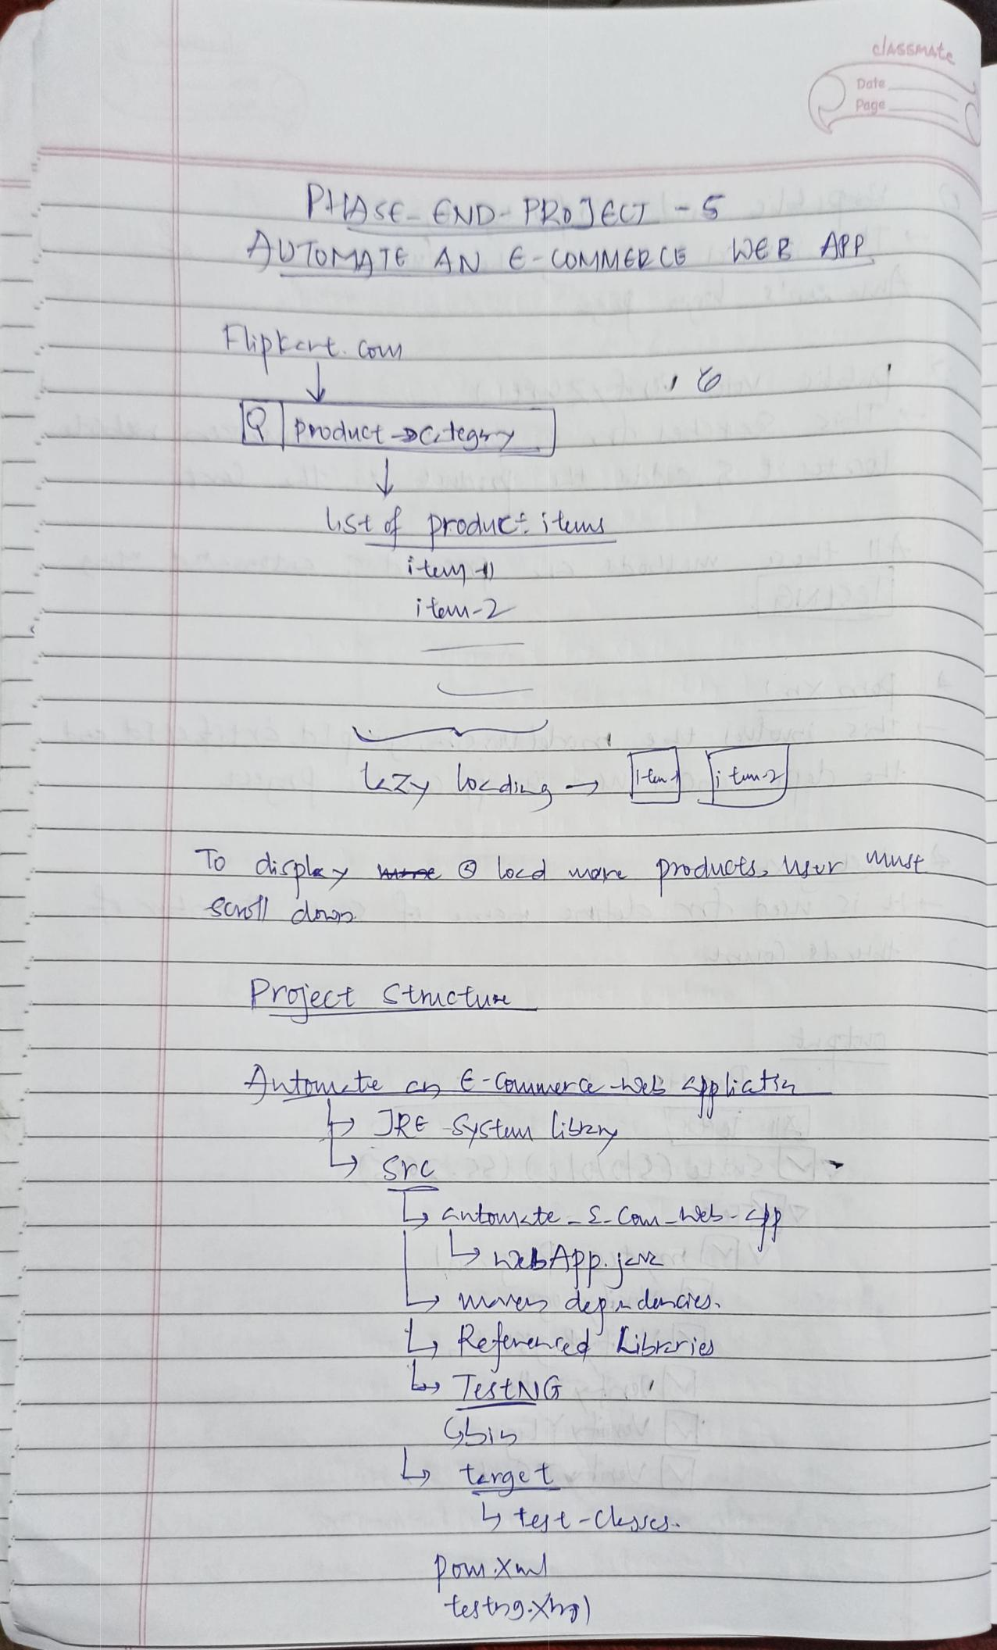
claGSMAte

Date

Page

PA sEEND PR1eC
JUTOMA 16 ANE-COMMERCE WE P AYP

hpbevt Cow

Product-DCAtg7

St producs iiumd

im
iton-2

zy d
lo dkapley _{ee} _{lod wa} ^{Pmduot,wur} ^{st}
COMs_cnao

Praect Ctmet

RESct Lzy
Sre

entowMte- S_Caaa
bPp
2ww dupn du-u
LRest d Llriu
LTutNG

Turget

y tut-Cs

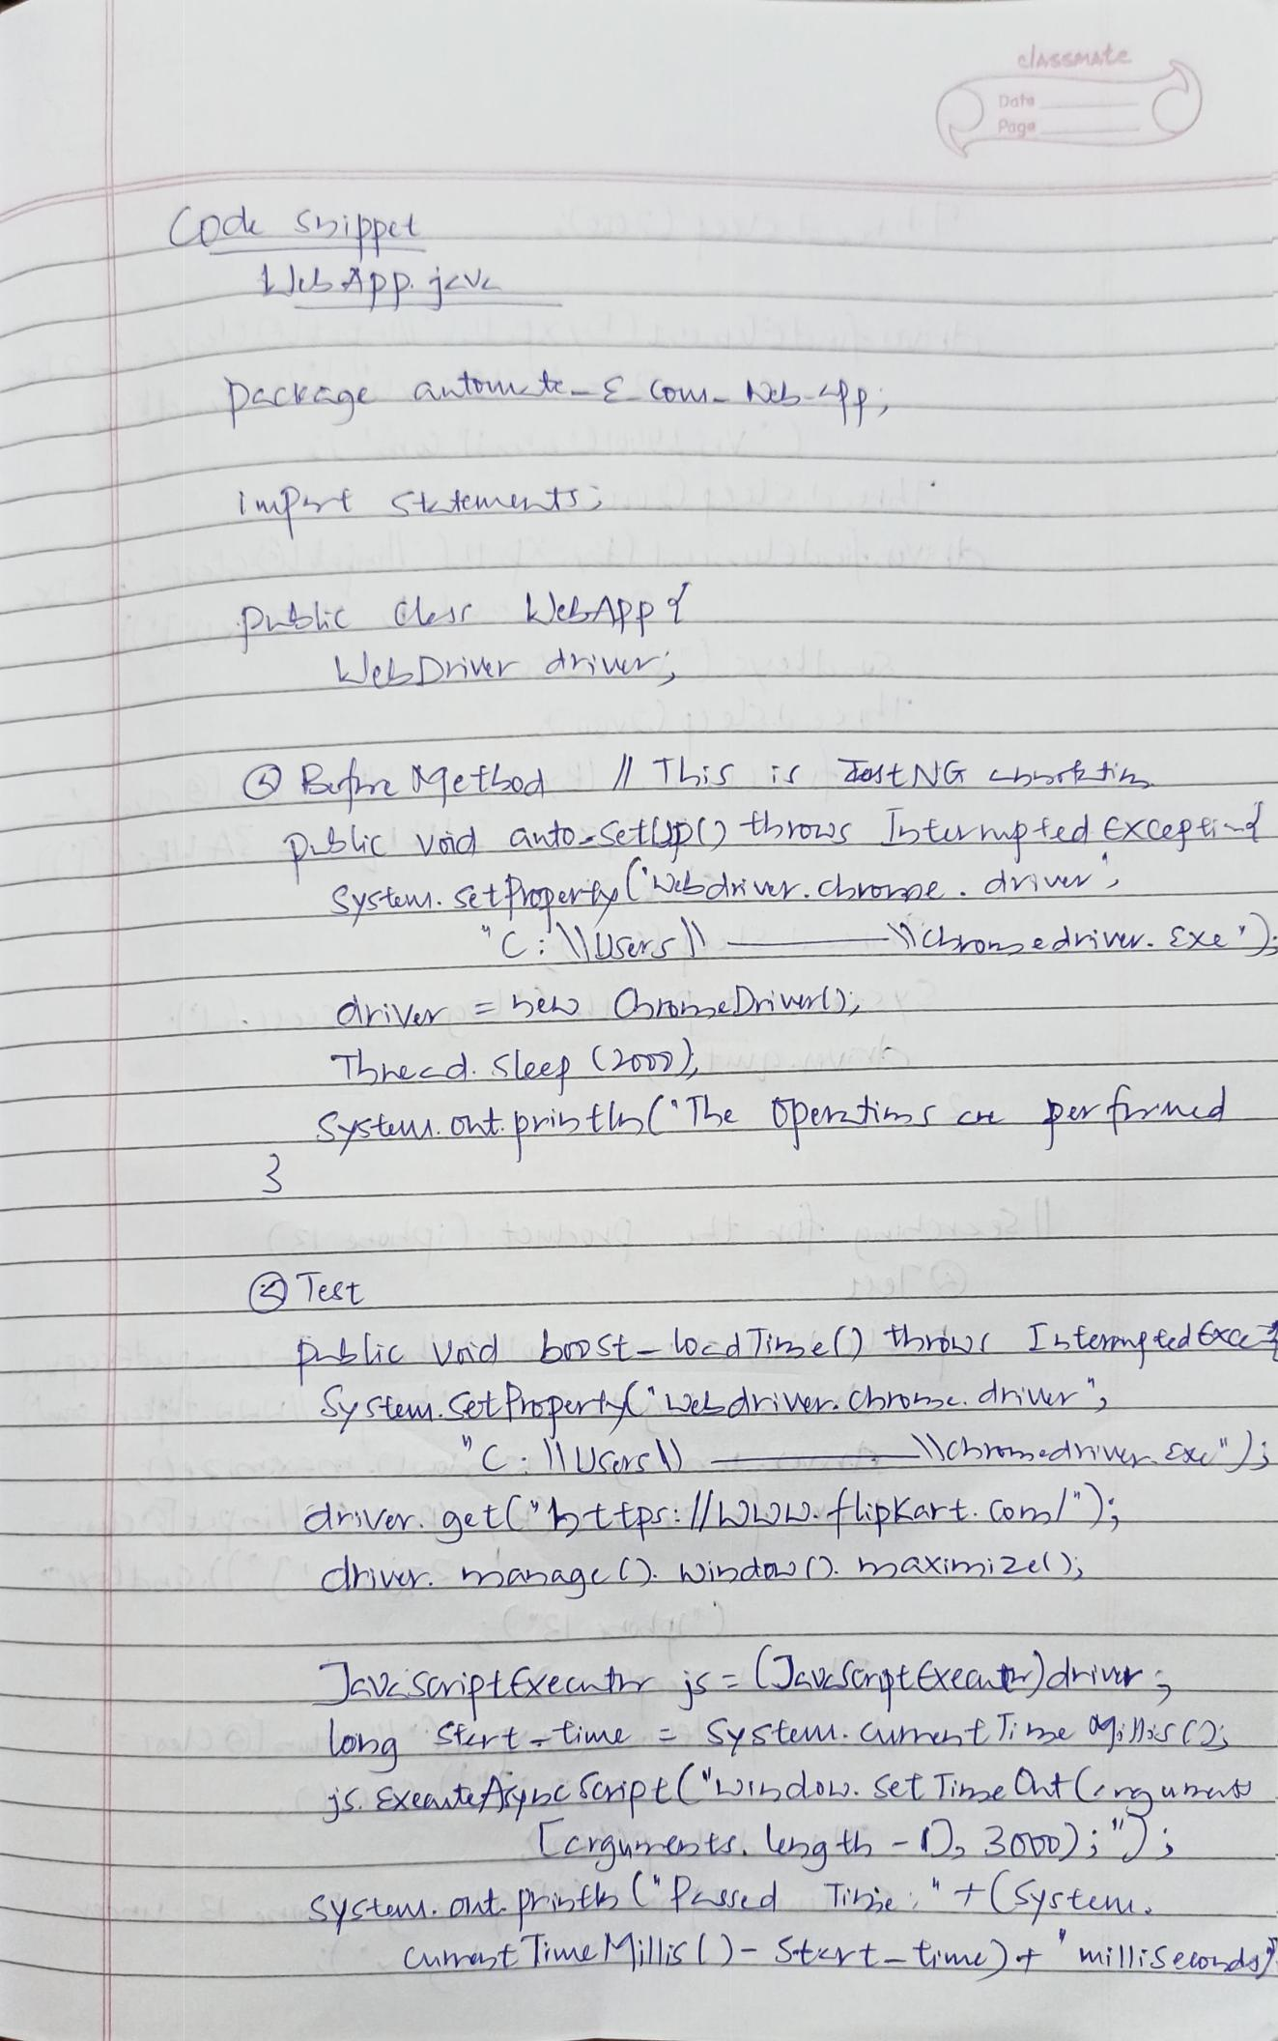
alassmate

Dafe
Page

Cod Shippet
JLApp j

Deckca Am E Cw-

WelDriwr dhw

Br MetLod LiS io1t NG btta

tc V.nd atDSetUp) hm btwwp ted excep
_{Systewn.} StPoper-ty Ldi w camne. ^{driw}
C \Uers\-

driVex heu bhbeliwd)

Thed Sleep Oomn)
_{Sstus.ht priy} tlbThe Opemtic c p ^{pend}

_{pLlic Vnd} bm St-loedlie) hyTLtom ^{td Exe}
SyHem. a Pnpet LLdne Chnha dnur
UGr)-
dhvr gethttpr:l/LOL.tpkert.oal

Chw mmaa Dindns D. hoaXihni2e ),

JeV Soipifxecmbis ENSCnatEXEat)driY

Lona Strt -time Sysum.Caunmuati be M }S CO
ExCaurne Scnpt(bibdL. Set ibe Ot (2mun
Leraurts. zqth- 30p):")
syam. at. prith P2ssd T t(Syrtuuu

Cmhtie illicD- Steyt-time)t milliS elods?

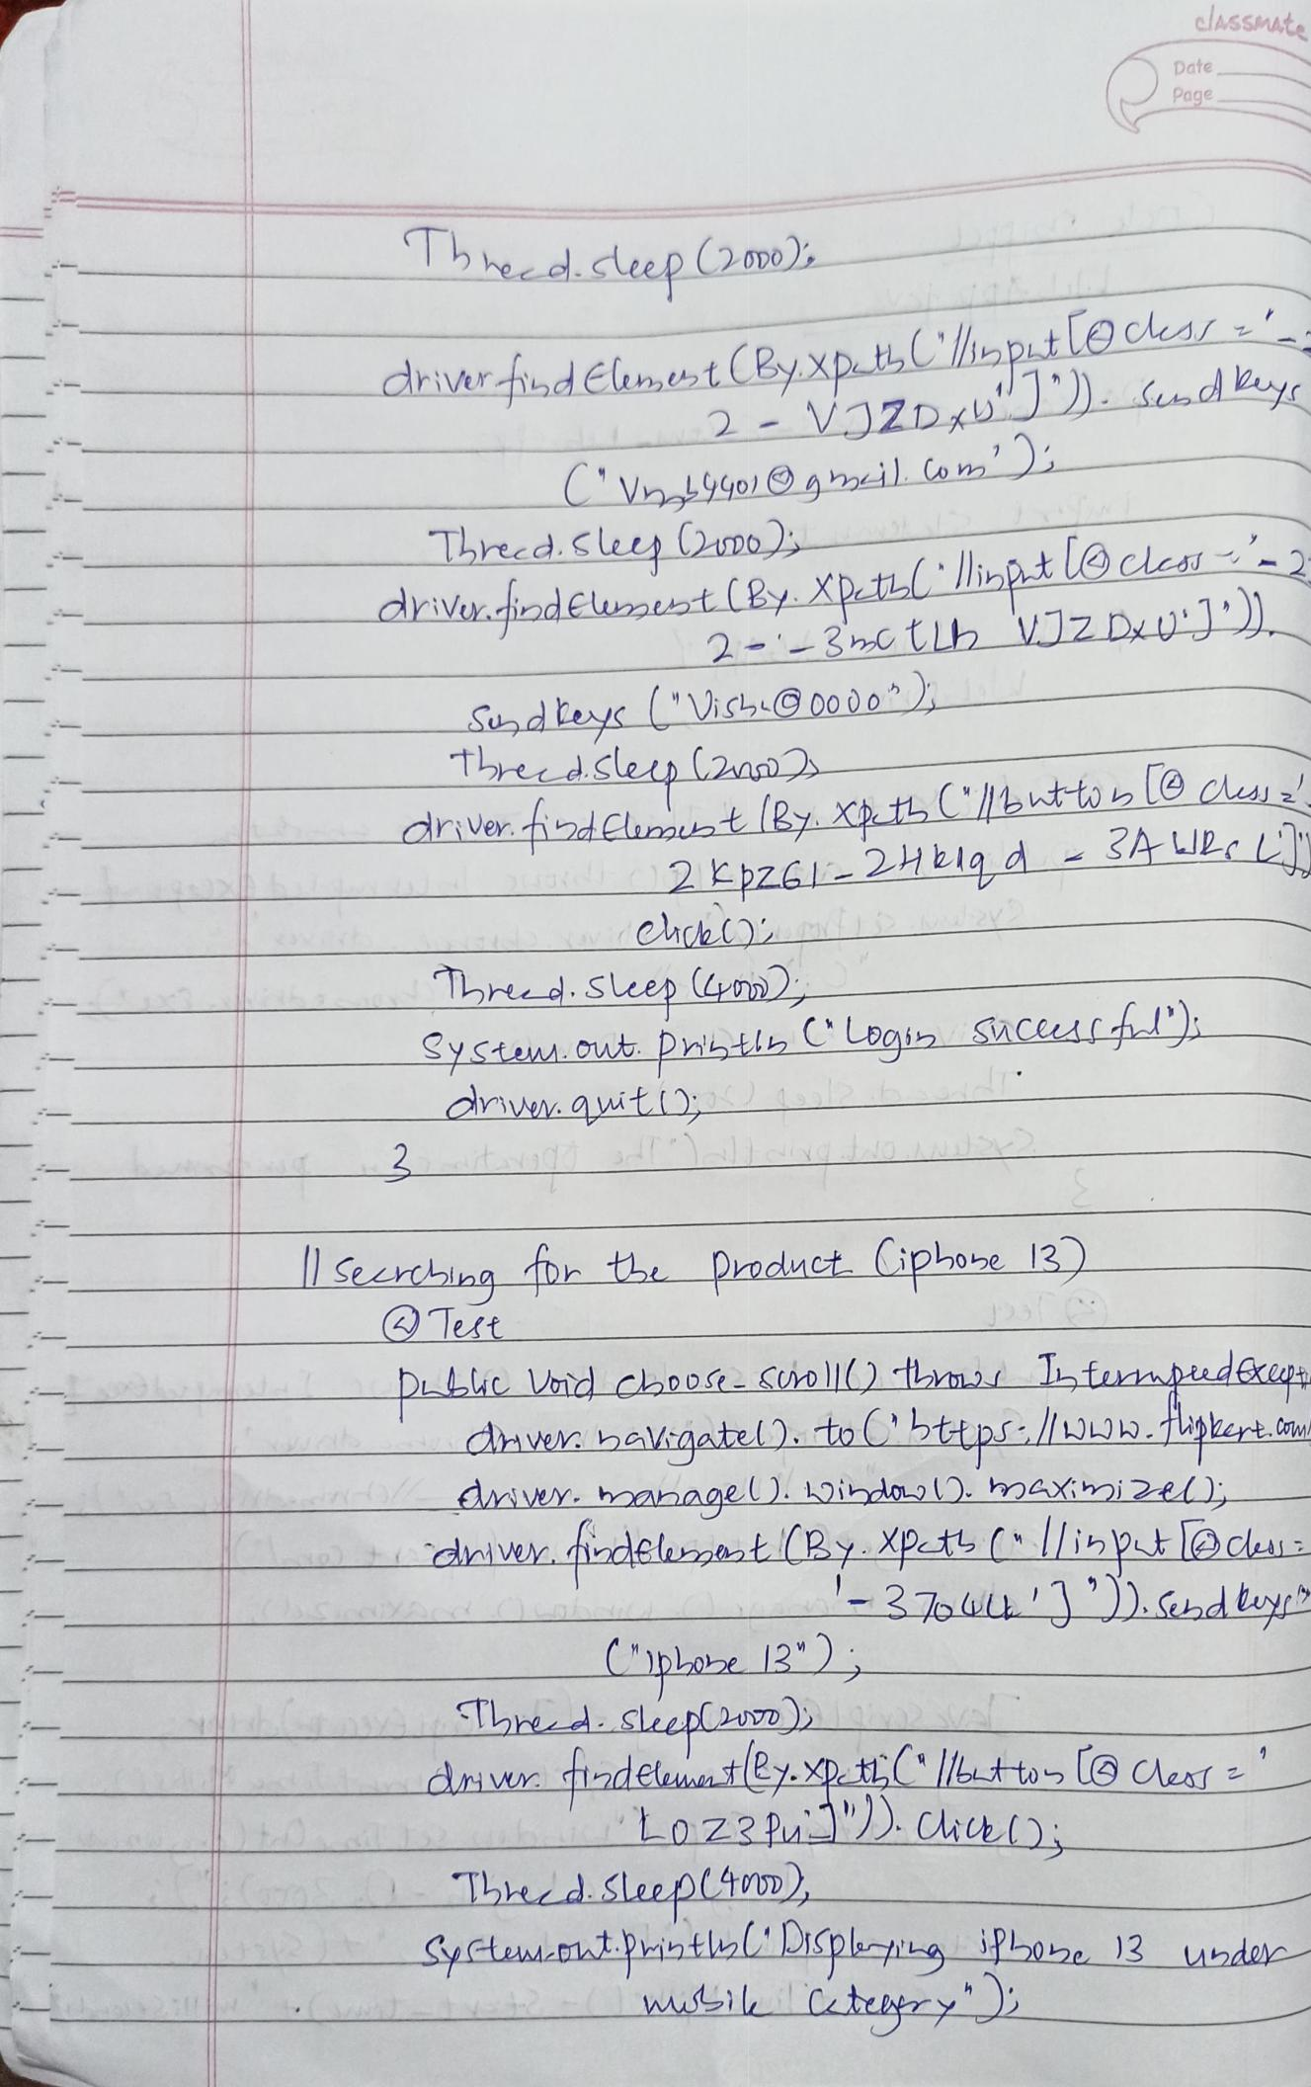
elAsSMAte

Date

Page

Tbed.dep (20v0
_{El,t} _{CByxp.t} ptLe ^{ceAs} ^{- ' _.}
^{dhiverd} _{VJZD;UJD) .} Kud^{b}
2 -
V990) htil Co)
^{Led.Suey Ono)} _{XptL} iptlOcles
driv.ciod.ewo ^{(By} _{tlh VZ DUJ"}
2 - 3p
_{Ssd}eyc(ViLO00do
ThecdSlep l2as

₂ EbzG - 24bld - SA ^{ULLy}
Cack
h Suep m)
_{Syctw.} Cut pnibl ^{CLoqi} ^{ucAAL)}
rivey gitD

2

| _{Sezlng} D th poduct iphoe 13)

DLLA Vaid cho0 Sill) Ln tusmpirdccu

dHwrbaVgatel). toC"btAps/O.fpteptta

ivwy boanaoe. 1oibdoo ) . mAXhi2e)

ceivexidelupt ByXptL (li>ptl@cda

CpLob 13)

She SleepCoD)
diw d-adelumanty.Xp tLC |Ltto lG CAest
Lozzu2.Chc0
ThhzdSLeepltvm

yctm-ttPintlul'LsplLg iPLo2e 13uzdee

wi Ctebery

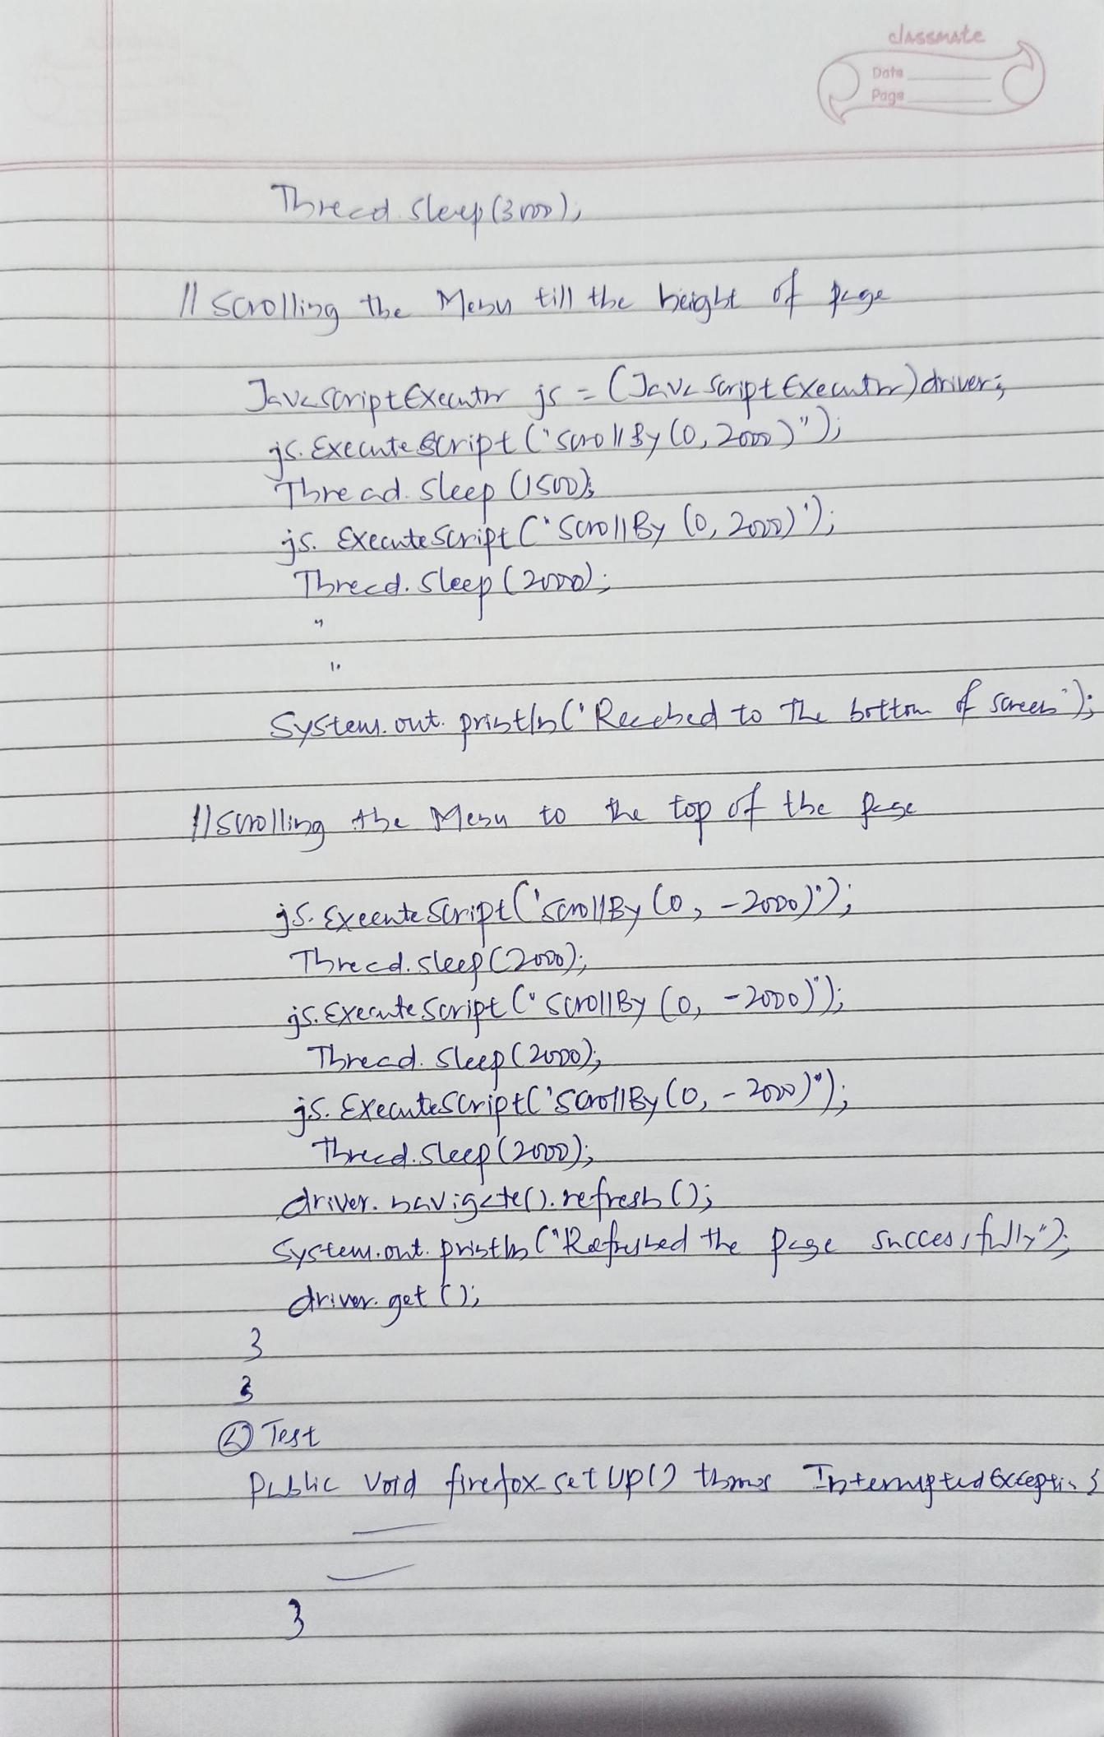
alssMate

Date
Page

bed cleep Bm-

_{viptxuti} JV iptExe ^{Late)dile}
_{Extute} Stript C So By ^{(0,2a)"))}
recd sleep (1
_{xtct} SLiptC'ooB l,²⁰⁵⁾ ^{);}
Thred.Cleep (202D)_

_{Sycte} _{ow} pribtn Rbd to L ^{brttn} ^{S}
_{Sellin} th Mu to top d ^{the p}

Thred clepC2
_{CXecte} Soript."Crol|1B (o, ^{-mo))}
Thrred SleepmD
_{is EXeautCiptC}'s&rBy (o, ⁻²⁰⁾⁾
edupm)

_{Syctum.nt} prietl Repiled the ^{pesSCCeshJ2 _}

ivet (

